**SSE3308 Lab Assignment 1**

Semester 2 2022/2023

Duration: 2 Weeks

**Question 1: Building a simple personal profile HTML page**

**Specifications:**

1. Your personal profile page will be well-formed HTML5 and indicate that it is in the UTF-8 character set.

<!DOCTYPE html>

<html>

<head>

<title>JaneStudent Matric# Lab1Q1</title>

<meta charset="UTF-8">

</head>

<body>

...

</body>

</html>

1. Your HTML must pass the validator at:

<https://validator.w3.org/nu/>

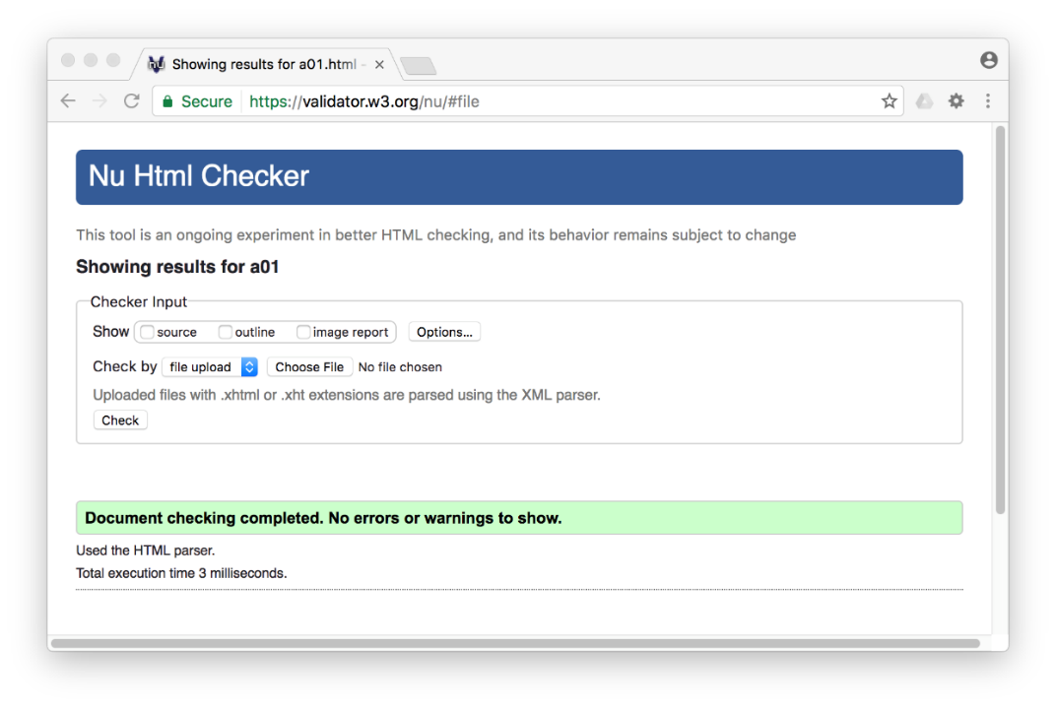

1. You must have at least one example of the following tags: ***span***, ***p***, ***div***, ***h1***, and ***ul***
2. You must have three ***a*** tags and three *li* tags.
3. You must have at least **one** table.
4. You must have at least **one** html absolute and relative link.
5. You must have at least **one** image right in the middle of the test like a character, and make it **clickable**.
6. You must have some **bold** text in the document and some **italics** text in the document but you **cannot** use the *b* or *i*tags.

**Hand In (via Putrablast):**

1. Image (JPG or PNG) of your [MatricNo_L1Q1].htm
2. The source code [MatricNo_L1Q1].htm
3. Upload your website to a free webhosting (e.g. 000webhost.com). Send the link.

**Question 2: develop a Cascading Style Sheet (CSS) to control, the look, feel, and layout of some provide HTML content**

**Specifications:**

You will transform from this:

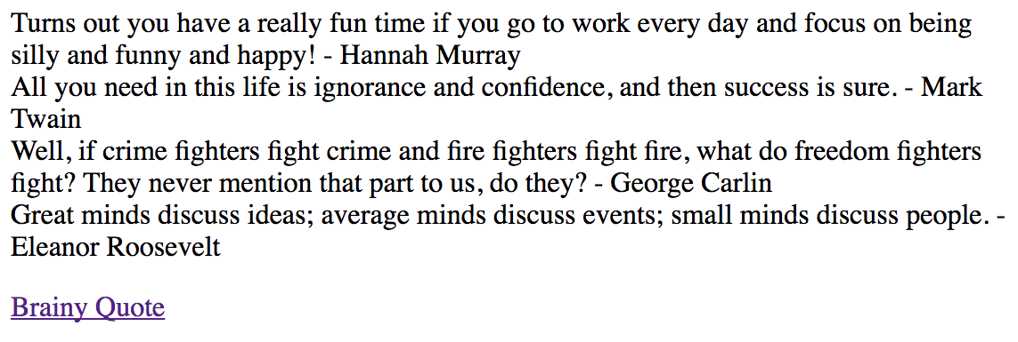

To this:

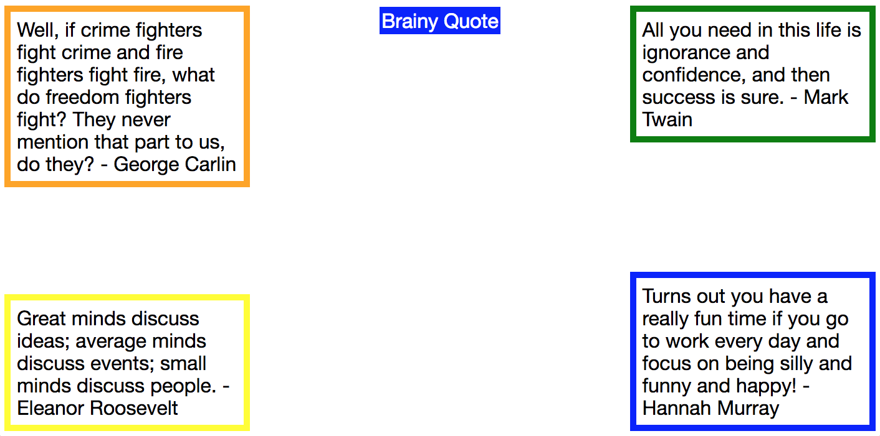

Using only CSS

**Pre-requisites:**

Please install the [Web Developer Toolkit](http://chrispederick.com/work/web-developer/) for your browser from Chris Pedrick and know how to use it to disable CSS styles.

**Tasks:**

Here are the tasks for this assignment.

* Take this [this file](https://www.wa4e.com/assn/css/index.txt) **index.txt** and copy/paste the contents into **index.htm**. You will **NOT** change this file.
* Take [this file](https://www.wa4e.com/assn/css/blocks.txt) **blocks.txt** and copy/paste the contents into **blocks.css** in the same folder as the above file.
* **EDIT** the blocks.css and add the CSS rules so it the HTML file looks like the above image when you view the index.htm file in your browser.
* The four boxes have 5-pixel borders with different colors and 5 pixels of margin and padding. It is probably simplest to use fixed positioning to get the boxes to be "sticky" to the corners of the screen even when you resize. Make the boxes width be 25% so the width changes as you resize your browser.
* Center the link at the top of the page. Use your developer console / inspect element feature of your browser to visit <https://www.brainyquote.com/> and figure out the background color, font, and text color they are using an replicate that exactly for the link in your index.htm.
* Your CSS must pass the validator at:

<https://jigsaw.w3.org/css-validator>

**Hand In:**

1. Image (JPG or PNG) of your index.htm with the styling applied
2. Image (JPG or PNG) of the source code of your blocks.css file
3. Image (JPG or PNG) of your blocks.css passing the W3 CSS validator
4. Image (JPG or PNG) of your browser viewing www.brainyquote.com with all styles turned off
5. Image (JPG or PNG) of your browser at www.brainyquote.com inspecting the navigation element to find its background color

**Sample Screen Shots:**

Using inspect element on the <https://www.brainyquote.com/>

SAMPLE

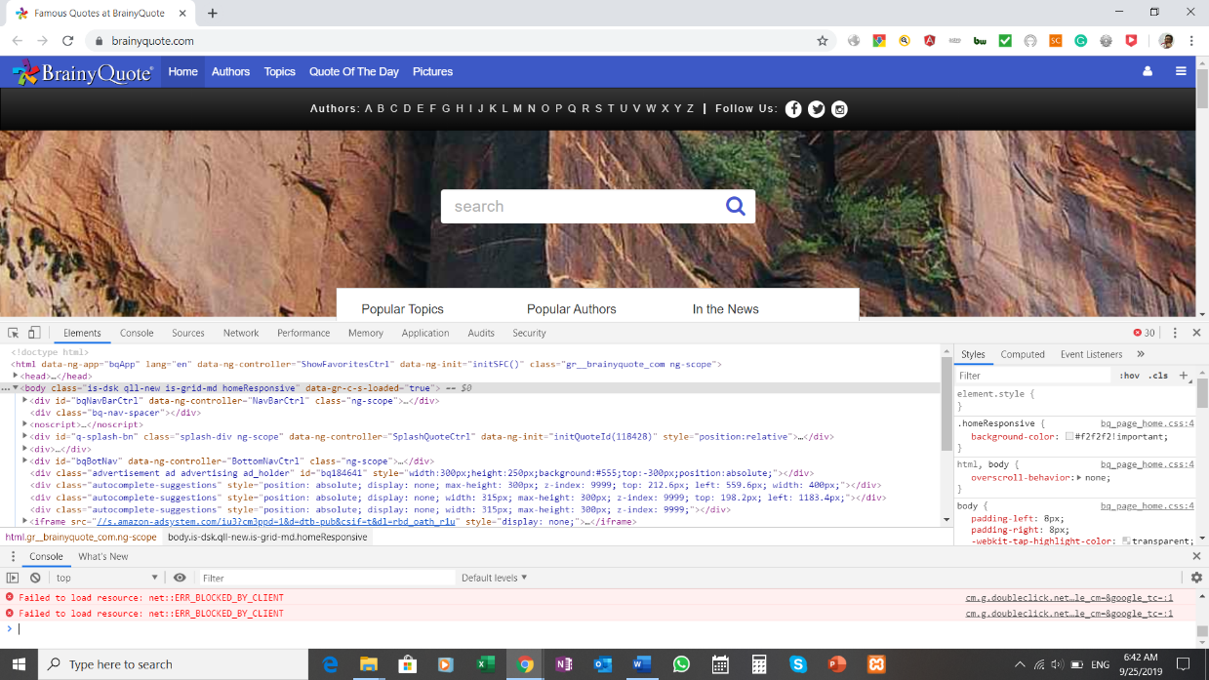

Looking at <https://www.brainyquote.com/> using Chris Pedrick's Web Developer add on to turn off all styles:

SAMPLE

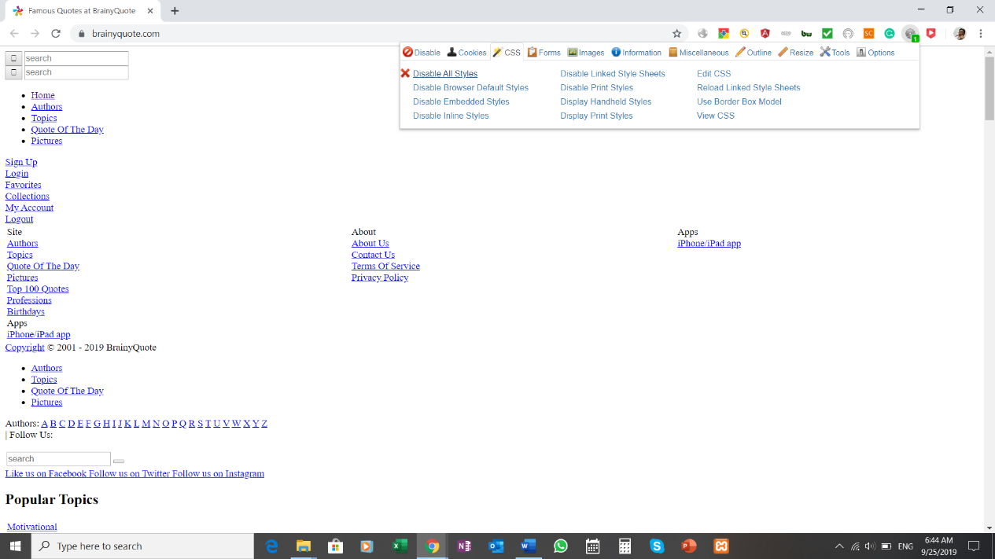

Passing the CSS validator:

SAMPLE

